Linked List

To understand Linked Lists we first have to look at lists because there are some issues with lists that Linked Lists try to solve.

Lists in Python are powerful and it is interesting to see how they are implemented internally.
List initialization
Let’s look at what happens when we initialize a new list.
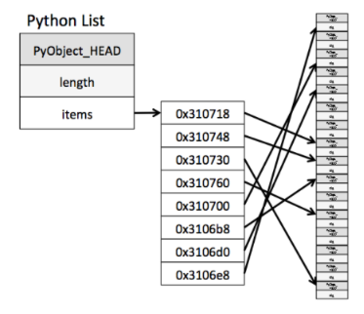
It is important to notice the difference between allocated slots and the size of the list. The size of a list is the same as len(l). The number of allocated slots is what has been allocated in memory. Often, you will see that allocated memory can be greater than size. This is to avoid needing calling realloc each time a new elements is appended to the list.
realloc() → is a function used to reallocate the memory.

Append
Imagine we create a new empty list: l=[]. We append an integer to the list: l.append(1). What happens?
It over-allocates memory to avoid allocating memory everytime we append a new item in the list.
The growth pattern of the list is: 0, 4, 8, 16, 25, 35, 46, 58, 72, 88, …
4 slots are now allocated to contain elements and the first one is the integer 1.You can see on the following diagram that l[0] points to the integer object that we just appended.
The dashed squares represent the slots allocated but not used yet.
Append operation amortized complexity is O(1).
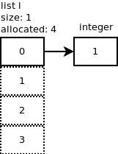
We continue by adding one more element: l.append(2). Since the allocated size is 4, there is no need to allocate more memory. Same thing happens when we add 2 more integers: l.append(3), l.append(4). The following diagram shows what we have so far.
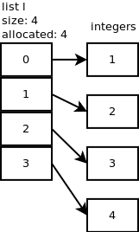
Below is another image that shows how memory continues to be allocated during appending.
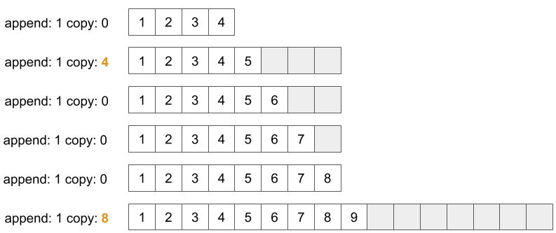
Insert
Let’s suppose we have a list l=[1,2,3,4] then we insert a new integer (5) at position 1: l.insert(1,5) and look at what happens.
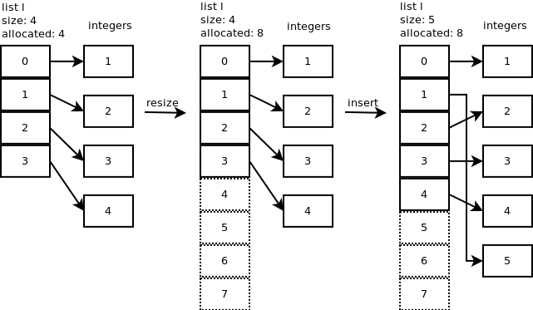
Here, 8 slots are allocated but the size or length of the list is only 5.
Inserting a new element in a list of elements is expensive because the room has to be created for the new elements and to create room existing elements have to be shifted. In our case all the integers 2, 3, 4 had to be shifted so 5 could be inserted at index=1. Imagine if there were 10000 elements.
Insert operation complexity is O(n).

Pop
When you pop the last element: l.pop()
If the new size is less than half of the allocated size then the list is shrunk to (size_of_list * 2).

Pop operation complexity is O(1).
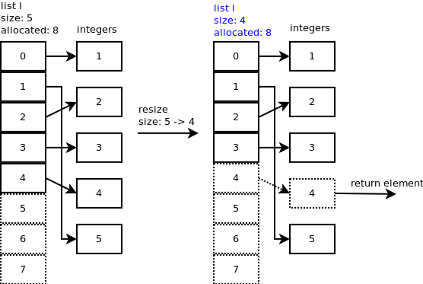
You can observe that slot 4 still points to the integer but the important thing is the size of the list which is now 4.
Let’s pop one more element.
Now size – 1 = 4 – 1 = 3 is less than half of the allocated slots so the list is shrunk to 6 slots and the new size of the list is now 3.
You can observe that slot 3 and 4 still point to some integers but the important thing is the size of the list which is now 3.
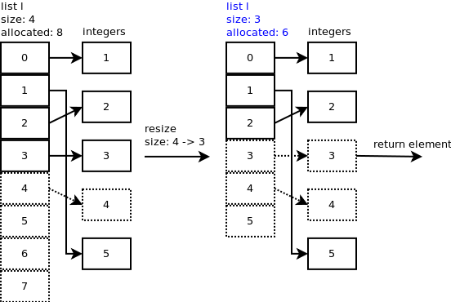
Remove
Python list object has a method to remove a specific element: l.remove(5)
Deletion is also expensive with lists until. For example, to delete element 5 in list, everything after 5 has to be moved due to this so much work is being done which affects the efficiency of the code.
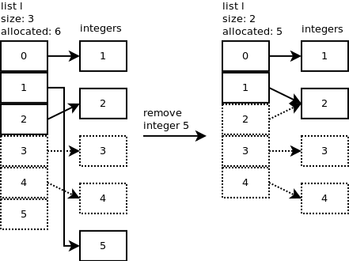
Remove operation complexity is O(n).
What are Linked Lists ?
Linked Lists are among the most fundamental data structure that represents a sequence of nodes. The first element of the sequence is called the head of the Linked List while the last element corresponds to the tail.

Each node in a list consists of at least two parts:
1. data (we can store integer, strings or any type of data).
2. Pointer (Or Reference) to the next node (connects one node to another)

Every node in the sequence has a pointer to the next element and optionally a pointer to the previous element.
In Singly Linked Lists each node points to only the next node.
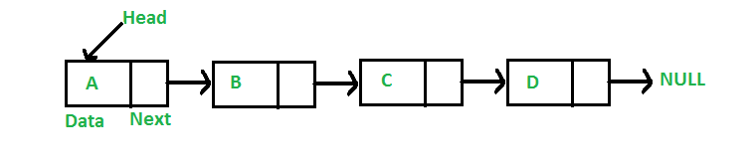
On the other hand, in Doubly Linked Lists each node points to the next as well as to the previous node.
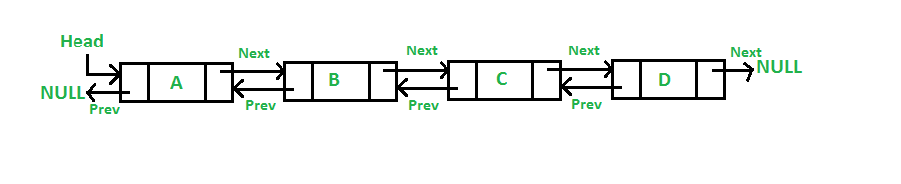
Advantages of Linked List

Better use of Memory:
From a memory allocation point of view, linked lists are more efficient than arrays. Unlike arrays, the size for a linked list is not pre-defined, allowing the linked list to increase or decrease in size as the program runs. This is possible because to insert or delete from a linked list, the pointers need to be updated accordingly.
Generally, inserting a node into a linked list requires the pointers to be updated after the new node is initialized. Figures below show how to insert nodes to the beginning, middle or end of a list.
Insert node at the beginning
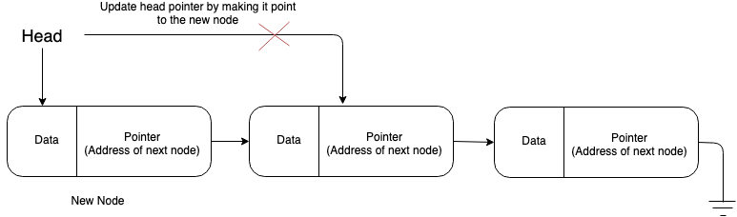
Insert node at the middle
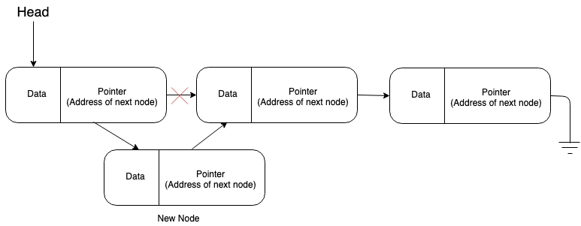
Insert node at the end
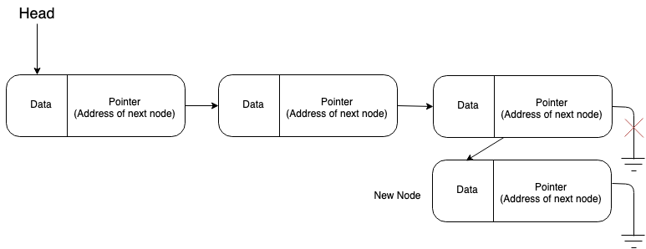
Even easier than inserting, is deleting from a linked list. The only step is to update the pointers of the nodes. Figures below show how to delete nodes to the beginning, middle or end of a list.
Delete node at the beginning
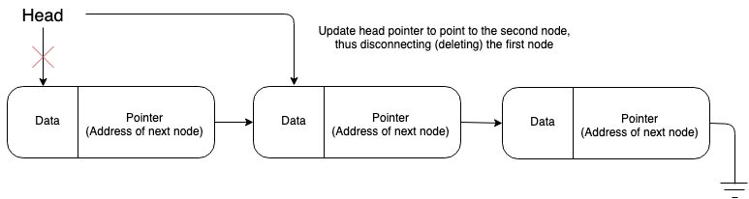
Delete node at the middle
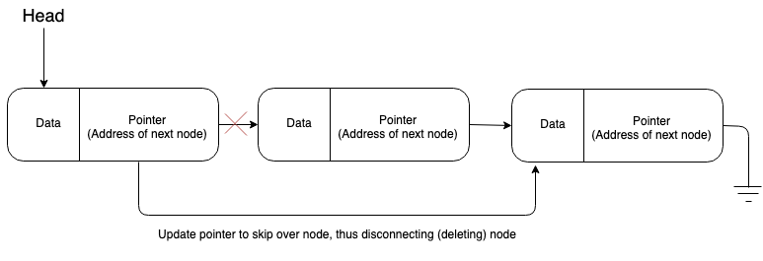
Delete node at the end
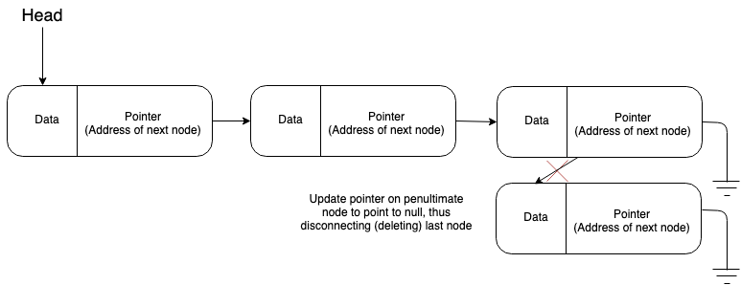
As shown in the figures above, inserting and deleting from a link list is quite simple. Furthermore, linked list structures prevent wasted memory as nodes are inserted into the list as they are initialized.

Disadvantages of Linked List
Linked list have slower search times than arrays as random access is not allowed. Unlike arrays where the elements can be search by index, linked list require iteration. This means that if you want to get the data on the tenth node, the head pointer can be used to get to the first node, the pointer on the first node can be used to get to the second node, and so forth until the tenth node is reached. This means that the more nodes that must be iterated while searching for a node, the longer the search time. This implies that the search time for linked list is linear time or Big O of n (O(n)).
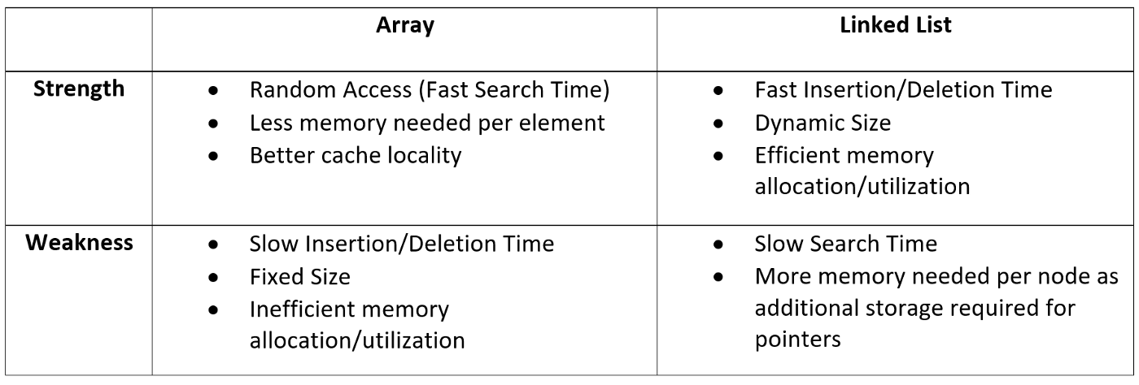

Python does not have a built-in implementation of Linked Lists in its standard library. Now we will learn how to implement a user-defined Linked List class using Python.

Check the Implementation under folder Linked_List→ linked_list.py file

Exercise 1)
- Create two classes one representing the Node and another representing the LinkedList.
- Improve the LinkedList to get a list of nodes as parmeter when created
- Use a magic method to print the data of the linked list in this form: a->b->c->None
- Use a magic method to get the length of the LinkedList
- Create a method push(self, new_data) to insert a node in the beginning of the LinkedList
- Create a method pop(self) to remove the last element from the LinkedList
- Create a method append(self, new_data) to insert a node at the end of the LinkedList
- Create a method insert_at(self, index, new_data) to insert a node at desired index of the LinkedList
- Create a method remove_at(self, index) to insert a node at desired index of the LinkedList
- Create a method insert_after(self, index, new_data) to insert a node after desired index of the LinkedList
- Create a function to reverese the linked list reverse(self). Example: from: a→b→None to: b->a->None
- Create a function to swap places of two nodes on a linked list. swap_nodes(self, x,y)

